**Website for Online Food Order System (www.foodtrucks.com)**

A Major Project   
Submitted in partial fulfillment of the requirements for the   
Award of Degree of BCA

**2015 – 2018**

**Submitted By: - Project Guided By:-**

**Gurpreet Singh Mrs. Megha Sehgal**

**Raj Kumar Sharma**



**BHARATI VIDYAPEETH DEEMED UNIVERSITY**

**SCHOOL OF DISTANCE EDUCATION**

**Academic Study Center - BVIMR, New Delhi**  
**An ISO 9001:2008 Certified Institute  
NAAC Accredited Grade “A” University**

# Student Undertaking

This is to certify that “**Gurpreet Singh”** and **“Raj Kumar Sharma”** had completed the Project Website on “**FOOD TRUCKS**” under the guidance of “**Mrs. Megha Sehgal”** in the partial fulfillment of the requirement for the award of degree of **Bachelor of Computer Applications** of **BVDU, SDE, Academic Study Center BVIMR, New Delhi**.   This is an original piece of work & we have neither copied and nor submitted it earlier elsewhere.

**Students Name and Signature:**

**Gurpreet Singh (0152BCA011)**

**Raj Kumar Sharma (0152BCA035)**

**Course:** BCA

**Date:**

# Acknowledgement

We deem it a time bound privilege and function to dedicate this page of us to a number of helping hands their cooperation & guidance that enabled us to dedicate time and effort in framing our analysis into a Conceivable system. Our most sincere thanks to the following persons who have given their valuable time in helping us go about our project. We wish to thank **Mrs. Meghas Sehgal mam,** for her guidance and encouragement and the staff of BVIMR. Above all we wish to thank our parents for their constant and wholehearted support through the project. We wish to thank **Mr. Amarjit R. Deshmukh,** the director of BVDU SDE for his constant support.

**Students Name and Signature:**

**Gurpreet Singh (0152BCA011)**

**Raj Kumar Sharma (0152BCA035)**

**Course:** BCA

**Date:**

# CONTENT

**CHAPTER 1 INTRODUCTION**

1.1      Introduction about Company   
 1.2      Introduction about Project  
 1.3      Present state of the art  
 1.4      Need of Computerization of System  
 1.5      Proposed Software  
 1.6      Importance of the Work

**CHAPTER 2 SYSTEM ANALYSIS**

2.1      Feasibility Study of S/W includes its types  
2.2      Analysis Methodology (Types)  
2.3      Choice of Platforms S/W & H/W  
 2.3.1   Software used  
 2.3.2   Hardware used

**CHAPTER 3 SYSTEM DESIGN**

3.1      Design methodology  
3.2      Form and Screen design       
3.3      Screen Design             
3.4      Coding parts

**CHAPTER 4 TESTING AND IMPLEMENTATION**

4.1      Testing Methodology (Types)   
4.2  Units Testing  
4.3  Modules Testing  
4.4      System Testing  
4.5      Alpha/ Beta Testing  
4.6      Implementation  
4.7      Post Implementation

**CHAPTER 5       CONCLUSION AND REFERENCES**

5.1      Conclusion  
5.2      Future Scope for Modification  
5.3    Requirements  
 5.3.1   H/W Requirement  
 5.3.2   S/W Requirement  
5.4      Limitation of System  
5.5      References/Bibliography

# ****CHAPTER 1****

# ****INTRODUCTION****

1.1    Introduction about Project  
1.2     Present state of the art  
1.3      Need of Computerization of System  
1.4      Proposed Software (What would s/w accomplish)  
1.5      Importance of the Work

# 1.1 Introduction about Project

**Website for Online Food Order System** will provide a basis for effectively fulfillment of customer requirement. As online ordering has brought a lot of change in customer experience we are selling meals. Customer can order any type of meal by just one click.

Like: - **HTML, CSS, JAVASCRIPT,** etc.

**All the features that we are providing our website and which works will be covered under the proposed features in detailed.**

The website is user friendly and easy to access. This website is already developed for use but can be further modified or updated as and when required on the request of the client. For work in proper manner the website used in the design were divided.

This project is beautifully designed with lot of tools and controls making it attractive from the user point view. The color combinations used were of the client’s choice with the mixture of suggestions from the designers.

# 1.2 Present state of the art

# This website (www.foodtrucks.com) is made for all people and users who want to check and test their knowledge in a few minutes. In the website we will add some features good information and great look and feel which is easy for the user.

# 1.3 Proposed Software (What would S/W accomplish)

The proposed solution of the problem is to putting an advanced website which will have functionalities the existing website does not hold. The problem was also in getting the similar, relevant and consisting images related to the organization. For this purpose new animations and images were developed using paint and Photoshop. The methodology used for this project was **Prototyping Model**.

Software prototyping, an activity during certain software development, is the creation of prototypes, i.e., incomplete versions of the software program being developed.

A prototype typically simulates only a few aspects of the features of the eventual program, and may be completely different from the eventual implementation. The conventional purpose of a prototype is to allow Users of the software to evaluate developers' proposals for the design of the eventual product by actually Trying them out, rather than having to interpret and evaluate the design based on descriptions. Prototyping can also be used by end users to describe and prove requirements that developers have not considered, so "controlling the prototype" can be a key factor in the commercial relationship between Solution providers and their clients. Firstly the Requirements of the client were discussed, which led to the rough design development of the web site. In this rough design some rough layouts were designed and conversed with the clients. The clients then decided the best suited format for their web site. After this step the next step was to use tools and design with colors and other text related tools. This step was taken in various periodic shuffling between the client and the designers where timely inputs were taken from the client. As when the client asked for certain changes they were made.

Finally after various shuttling the product so developed was the final layout of the website which was then tested using black box technique and ready to be published.

**PHASES**

Feasibility Study

System Analysis

Requirement Analysis

Implementation

Testing

Testing

Design & Coding

Feedback

**1.4 Importance of work**

Advantages of project

* User friendly
* Very easy to access
* Provide all recent updates
* Flexibility
* Provide interface for User

**CHAPTER 2**

# SYSTEM ANALYSIS

2.1 Feasibility Study of S/W and Includes its types  
2.2 Analysis Methodology (Types)  
2.3 Choice of Platforms S/W & H/W  
 2.3.1      Software Used  
 2.3.2      Hardware Used

**2.1 Feasibility Study of Website and Includes Its Types**

The basic purpose of feasibility study or survey is to determine whether the whole process of system analysis leading to

**Computerization would be worth the effort for the organization.**

A website would take the place of the **expense, hassle, and delays of product brochures.** The link will point potential users to the link. As new features are added, site visitors would see them listed.

Feasibility study asks whether the managements’ concept of their desired new system is actually an achievable, realistic goal, in terms of money, time and end result difference to the original system. Often, it may be decided to simply update an existing system, rather than to completely replace one. In **Online Food Order System** we have updated the existing website by adding new images, attractive color combinations and interactive Feedback form.

One concern is a conundrum - the site requires the very technology offered to potential customers -- web access. If people can get on the web, they wouldn't need the site. However, the site is also intended to motivate and coordinate volunteers (staff), to serve the administrative aspects of the organization

The feasibility study results in the preparation of a report called the Feasibility Study/ Survey Report, which is submitted to the management for consideration. It contains the following details:

* A proposed solution to the problem
* Rough estimate on the cost/benefits analysis if the solution is implemented
* Approximate time, effort and cost estimates for completion of the project

# Types of Feasibility Study:-

* Economic Feasibility
* Technical Feasibility
* Operational Feasibility
* Behavioral Feasibility
* Schedule Feasibility

# Economic Feasibility

Economic analysis is the most frequently used method for evaluating the effectiveness of the new website most commonly known as cost/benefit analysis. It is the procedure to determine the benefits and savings that are expected from the new website and compare them with costs. If benefits overweigh costs, then the decision is made to design and implement the new website. Otherwise, further justification or alternations in the proposed system will have to be made if it is to have a change of being approved. The purpose of the economic feasibility assessment is to determine the positive economic benefits to the organization that the proposed system will provide. It includes quantification and identification of

all the benefits expected.

In developing cost estimates for the website, we need to consider several cost elements. Among them are:-

* **Hardware Costs:-** relate to the actual purchase or lease of the computer and peripheralslike printer, disk drive, tape unit etc.
* **Facility Costs:-** or onetime costs are expenses incurred in the preparation of the physical site where the application or the computer will be in operation.
* **Supply Costs:-** are available costs that increase with the increased use of paper, and the like.

# Technical Feasibility

It is related to the software and equipment specified in design for implementing the new system. It confirms that the necessary technology .i.e. required for the proposed system exists in the organization. The technical feasibility assessment is focused on gaining an understanding of the present technical resources of the organization and their applicability to the expected needs of the proposed system.

It is an evaluation of the hardware and software and how it meets the need of the proposed system.

The issues involved are:-

* **Matching the configuration requirements:** Checking if the suggested solution will be supported by the existing technology, whether it is capable of sorting the volumes of data and meeting the further requirements related to the H/w and S/w.
* **Making the website secure:** The website should be secure enough so that no one can make use the information of the organization in a wrong or negative manner.

# Operational Feasibility

It is mainly related to human organizational and political aspects. Not only must an application make economic and technical sense, it must also make operational sense. The basic question that you are trying to answer is, “**it is possible to maintain and support this application once it is in production?**” Building an application is decidedly different than operating it, therefore you need to determine whether or not you can effectively operate and support it. The new and young staff does understand the need of such change in website. With the new website there will be no job-cutting process will be done. Rather, the organization is expecting that through the new website more and more people become aware of it and hence new applicants for various job profiles will approach. The new website will at some amount reduce paper work they have to do every day. The task distribution will remain the same.

There will not be a need of making all the staff members to teach a certain new skill to work on the new website as working on the world wide web is a kids play now a days.

# Behavioral Feasibility

The website is behaviorally feasible. People are inherently resistant to change and computers are known to facilitate changes. An estimate should be made on how strong reaction the user staff is likely to have towards the development. The system is mainly of use of the staff who will make necessary changes and updated as and when required and the people who will access the World Wide Web.

**2.1 Analysis Methodology (Types)**

System analysis is the most important phase in a system development. In this phase, the new website to be prepared is fully analyzed in all aspects. Analysis is actually a detailed study of the various operations performed by a system and their relationships within and outside the system.

**A key question is: what must be done to solve the problem?** One aspect of analysis is defining the boundaries of the system and determining whether or not the website should consider other related systems. During analysis, data are collected on the available files, decision points handled by the present website.

Some logical system models and tools that are used in analysis (Data flow diagrams, interviews) are commonly used tools in analysis. It requires special skills and sensitivity to the subjects being interviewed. Bias in data collection and interpretations can be a problem. Training, experience and common sense are

required for collection of the information needed to the analysis.

Once analysis is completed, the analyst has a firm understanding of what is to be done the next step is to decide how the problem might be solved. Thus, in a system design we move from the logical to the physical aspects of the life cycle.

**2.3 Choice of Platform**

**2.3.1 Software Used**

* This website was design in **HTML/CSS & JAVASCRIPT**. Then we come to the coding part of website for
* Coding we used a text editor called **(Notepad)** this is very good text editor for web developer.
* WINDOW 7 PC

These application are too complicated for non-technical person these require knowledge of HTML, CSS & JavaScript.

**2.3.2 Hardware Used**

The hardware used was: -

* Intel (Core i3)
* 2GB RAM
* 512 GB HDD

**CHAPTER 3**

**SYSTEM DESIGN**

3.1 Design Methodology  
3.2 Form/Screen Design  
3.3 Site Map  
3.4      Coding Part

**3.1 Design Methodology**

The term ‘**design**’ describes a final system, and the process by which it is developed. It refers to the **technical specifications** (like blueprints) that will be applied in implementing the website. Hence, it signifies how the website will meet the requirements which were specified during system analysis.

Design is a creative process requiring insight and flair on the pert of the designer.It must be practiced and learnt by experience and study of existing systems.

Any design problem must be tackled in three stages:

* Study and understand the problem
* Identify gross features of at least one possible solution
* Describe each abstraction used in the solution

**The progression from an informal to a detailed design**

**Informal design outline**

**Informal design**

**More formal design**

**Finished Design**

A good website design **engages visitors, makes it easy for them to navigate and compels them to explore further**. Attractive graphics that support the company’s message are important. But large graphics that take a long time to load frustrate users. Many visitors won’t wait long enough for the graphic to finish loading. Additionally, visitors are less likely to return to a site that has cumbersome or confusing navigation.

**User interface:** The user interface is the first and last element observed by a site visitor. User interaction design begins with the visual presentation best suited to delivering on user expectations. It then continues on to focus on the physical ways in which a user interacts with the site content. Good graphic design acts to **increase the communicative value** of the interface, which leads to increased user satisfaction. In test after test, it has been proven that the simplest websites are the most effective in service.

**Environment** - graphics should have a purpose, navigation easy and intuitive, and the interface uncluttered.

**3.2 FORM/SCREEN DESIGN**

This screen provides the user friendly way to understand each system. Screen are normally designed to control redundancy and to improve accuracy. If screen is designed carefully, the user will get help from them. They are used for the elimination of the unnecessary data. Data can be easily corrected.

**Fig 3.1 HOME PAGE**

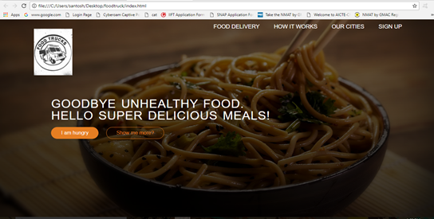

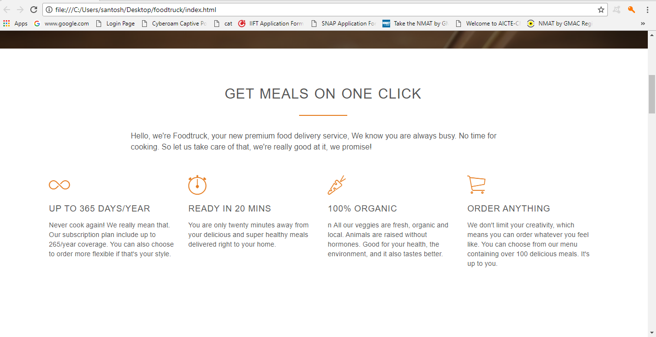

**Fig 3.3 MEALS**

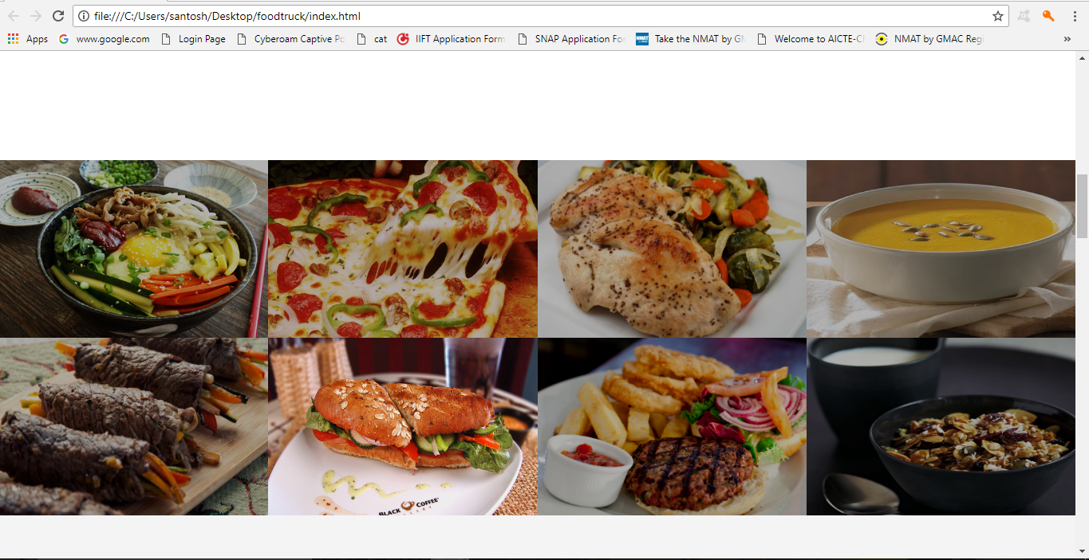

**FIG 3.4 PROCEDURE**

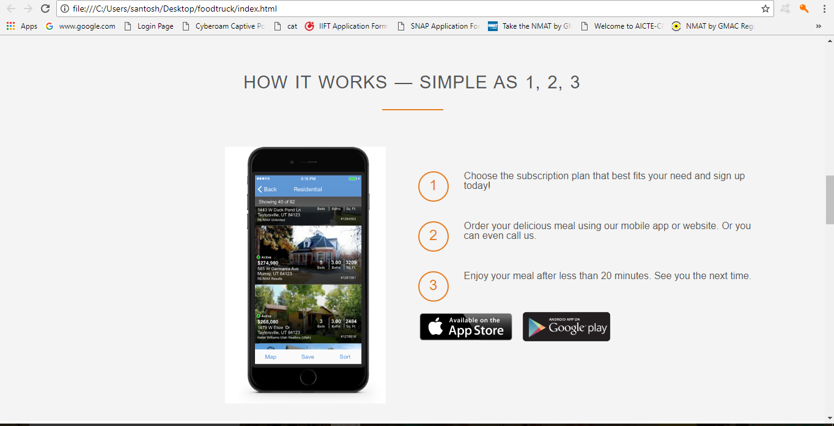

**FIG 3.5 OUR CITIES**

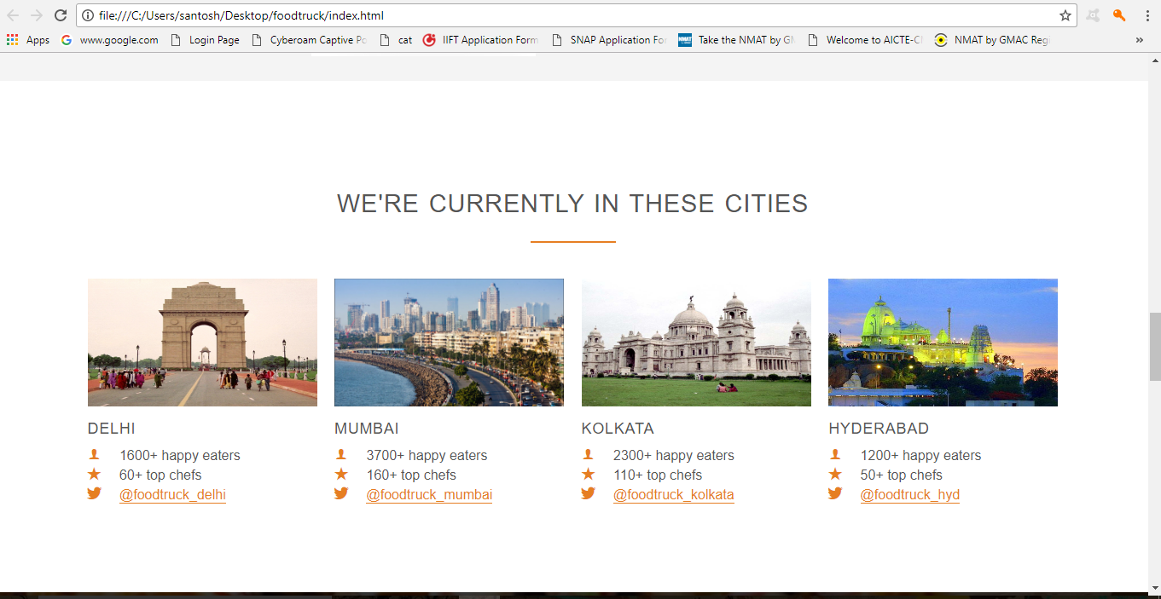

**Fig 3.6 FEEDBACK**

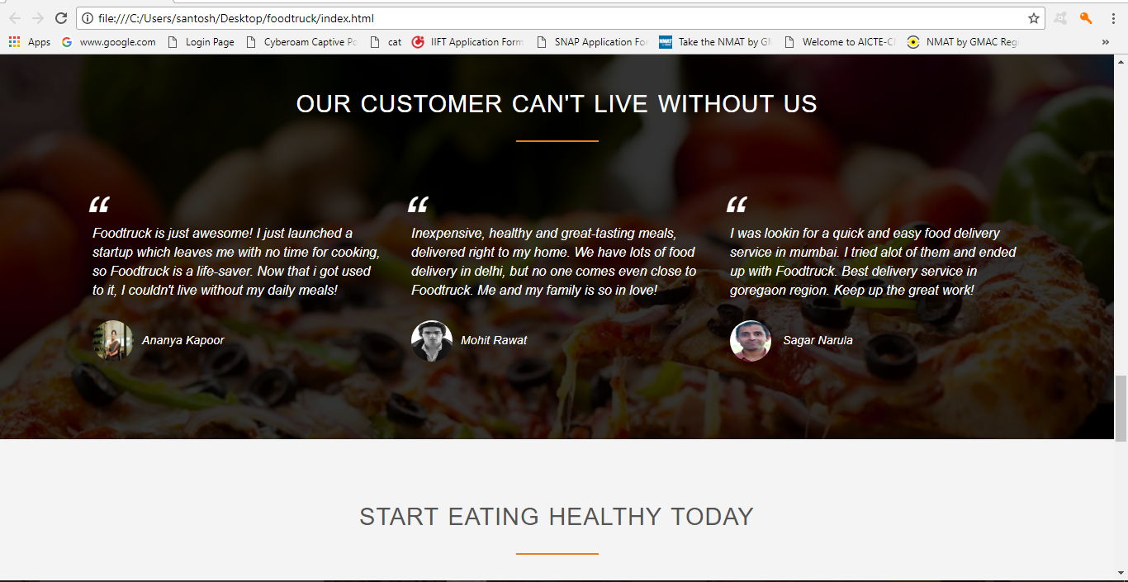

**FIG 3.7 SIGN UP**

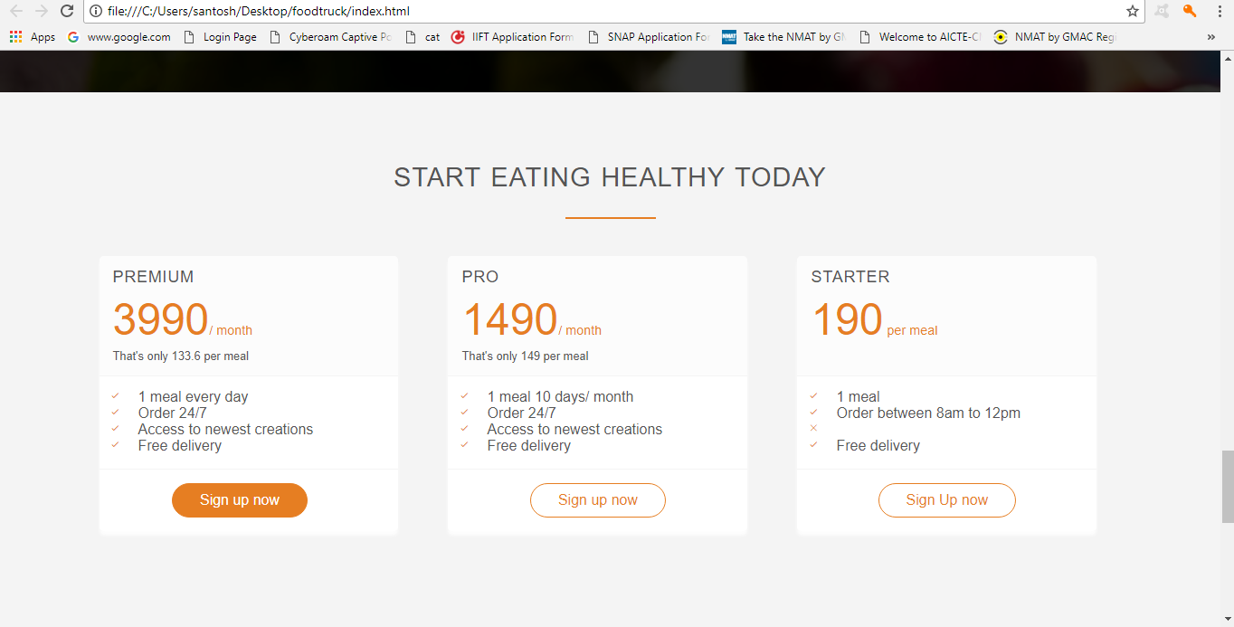

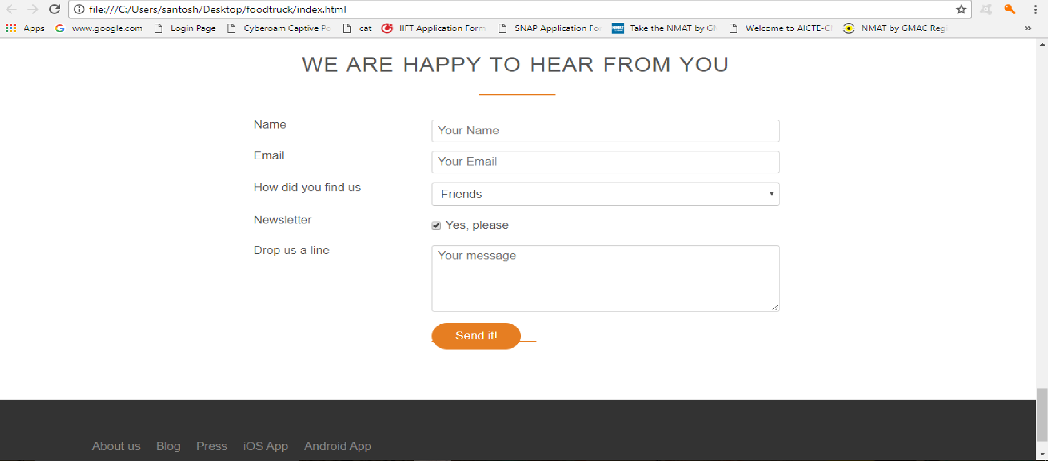

**3.3 SITEMAP**

**3.4 CODING**

<!DOCTYPE html>

<html lang="eng">

<head>

<link rel="stylesheet" type="text/css" href="vendors/css/normalize.css">

<link rel="stylesheet" type="text/css" href="vendors/css/grid.css">

<link rel="stylesheet" type="text/css" href="vendors/css/ionicons.min.css">

<link rel="stylesheet" type="text/css" href="resources/css/style.css">

<title>Foodtruck</title>

</head>

<body>

<header>

<nav>

<div class="row">

<img src="resources/img/foodtruck.jpg" alt="foodtruck logo" class="logo">

<img src="resources/img/foodtruck2.png" alt="foodtruck logo"class="logo-black">

<ul class="main-nav">

<li><a href="#more">Food Delivery</a></li>

<li><a href="#works">How it works</a></li>

<li><a href="#cities">Our cities</a></li>

<li><a href="#form">Sign Up</a></li>

</ul>

</div>

</nav>

<div class="hero-text-box">

<h1>Goodbye unhealthy food.<br>Hello super delicious meals!</h1>

<a class="btn btn-full"href="#plans">I am hungry</a>

<a class="btn btn-ghost"href="#more">Show me more?</a>

</div>

</header>

<section id="more" class="section-features jss--section-features">

<div class="row">

<h2>Get meals on one click</h2>

<p class="long-copy">

Hello, we're Foodtruck, your new premium food delivery service, We know you are always busy. No time for cooking. So let us take care of that, we're really good at it, we promise!

</p>

</div>

<div class="row">

<div class="col span_1_of_4 box">

<i class="ion-ios-infinite-outline icon-big"></i>

<h3>Up to 365 days/year</h3>

<p>

Never cook again! We really mean that. Our subscription plan include up to 265/year coverage. You can also choose to order more flexible if that's your style.

</p>

</div>

<div class="col span_1_of_4 box">

<i class="ion-ios-stopwatch-outline icon-big"></i>

<h3>Ready in 20 mins</h3>

<p>

You are only twenty minutes away from your delicious and super healthy meals delivered right to your home.

</p>

</div>

<div class="col span_1_of_4 box">

<i class="ion-ios-nutrition-outline icon-big"></i>

<h3>100% organic</h3>

<p>n

All our veggies are fresh, organic and local. Animals are raised without hormones. Good for your health, the environment, and it also tastes better.

</p>

</div>

<div class="col span_1_of_4 box ">

<i class="ion-ios-cart-outline icon-big "></i>

<h3>Order anything</h3>

<p>

We don't limit your creativity, which means you can order whatever you feel like. You can choose from our menu containing over 100 delicious meals. It's up to you.

</p>

</div>

</div>

</section>

<section class="section-meals">

<ul class="meals-showcase clearfix">

<li>

<figure class="meal-photo">

<img src="resources/img/1.jpg" alt="korean bibimap">

</figure>

</li>

<li>

<figure class="meal-photo">

<img src="resources/img/2.jpg" alt="simple italian pizza">

</figure>

</li>

<li>

<figure class="meal-photo">

<img src="resources/img/3.jpg" alt="chicken breast steak">

</figure>

</li>

<li>

<figure class="meal-photo">

<img src="resources/img/4.jpg" alt="autumn pumpkin soup">

</figure>

</li>

</ul>

<ul class="meals-showcase clearfix">

<li>

<figure class="meal-photo">

<img src="resources/img/5.jpg" alt="paleo beef steak">

</figure>

</li>

<li>

<figure class="meal-photo">

<img src="resources/img/6.jpg" alt="healthy baguette">

</figure>

</li>

<li>

<figure class="meal-photo">

<img src="resources/img/7.jpg" alt="burger with cheddar">

</figure>

</li>

<li>

<figure class="meal-photo">

<img src="resources/img/8.jpg" alt="granola with cherries">

</figure>

</li>

</ul>

</section>

<section class="section-steps" id="works">

<div class="row">

<h2>How it works &mdash; Simple as 1, 2, 3</h2>

</div>

<div class="row">

<div class="col span_1_of_2 step-box">

<img src="resources/img/iphone%20image.png" alt="foodtruck app on iiphone" class="app-screen">

</div>

<div class="col span_1_of_2 step-box1">

<div class="work-steps">

<div>1</div>

<p>Choose the subscription plan that best fits your need and sign up today!</p>

</div>

<div class="work-steps">

<div>2</div>

<p>Order your delicious meal using our mobile app or website. Or you can even call us.</p>

</div>

<div class="work-steps">

<div>3</div>

<p>Enjoy your meal after less than 20 minutes. See you the next time.</p>

</div>

<a href="#" class="btn-app"><img src="resources/img/app%20store.png" alt="app store button"> </a>

<a href="#" class="btn-app"><img src="resources/img/google%20play.png" alt="play store button"> </a>

</div>

</div>

</section>

<section class="section-cities" id="cities">

<div class="row">

<h2>We're currently in these cities </h2>

</div>

<div class="row">

<div class="col span_1_of_4 box">

<img src="resources/img/delhi.jpg" alt="Delhi">

<h3>delhi</h3>

<div class="city-feature">

<i class="ion-ios-person icon-small"></i>

1600+ happy eaters

</div>

<div class="city-feature">

<i class="ion-ios-star icon-small"></i>

60+ top chefs

</div>

<div class="city-feature">

<i class="ion-social-twitter icon-small"></i>

<a href="#">@foodtruck_delhi</a>

</div>

</div>

<div class="col span_1_of_4 box">

<img src="resources/img/mumbai.jpg" alt="Mumbai">

<h3>mumbai</h3>

<div class="city-feature">

<i class="ion-ios-person icon-small"></i>

3700+ happy eaters

</div>

<div class="city-feature">

<i class="ion-ios-star icon-small"></i>

160+ top chefs

</div>

<div class="city-feature">

<i class="ion-social-twitter icon-small"></i>

<a href="#">@foodtruck_mumbai</a>

</div>

</div>

<div class="col span_1_of_4 box">

<img src="resources/img/kolkata.jpg" alt="Kolkata">

<h3>kolkata</h3>

<div class="city-feature">

<i class="ion-ios-person icon-small"></i>

2300+ happy eaters

</div>

<div class="city-feature">

<i class="ion-ios-star icon-small"></i>

110+ top chefs

</div>

<div class="city-feature">

<i class="ion-social-twitter icon-small"></i>

<a href="#">@foodtruck_kolkata</a>

</div>

</div>

<div class="col span_1_of_4 box">

<img src="resources/img/hyderabad.jpg" alt="Hyderabad">

<h3>hyderabad</h3>

<div class="city-feature">

<i class="ion-ios-person icon-small"></i>

1200+ happy eaters

</div>

<div class="city-feature">

<i class="ion-ios-star icon-small"></i>

50+ top chefs

</div>

<div class="city-feature">

<i class="ion-social-twitter icon-small"></i>

<a href="#">@foodtruck_hyd</a>

</div>

</div>

</div>

</section>

<section class="section-testimonials">

<div class="row">

<h2>Our Customer Can't Live Without Us</h2>

</div>

<div class="row">

<div class="col span_1_of_3">

<blockquote>

Foodtruck is just awesome! I just launched a startup which leaves me with no time for cooking, so Foodtruck is a life-saver. Now that i got used to it, I couldn't live without my daily meals!<br>

<cite><img src="resources/img/anaya.jpg">Ananya Kapoor</cite>

</blockquote>

</div>

<div class="col span_1_of_3">

<blockquote>

Inexpensive, healthy and great-tasting meals, delivered right to my home. We have lots of food delivery in delhi, but no one comes even close to Foodtruck. Me and my family is so in love!<br>

<cite><img src="resources/img/mohit.jpg">Mohit Rawat</cite>

</blockquote>

</div>

<div class="col span_1_of_3">

<blockquote>

I was lookin for a quick and easy food delivery service in mumbai. I tried alot of them and ended up with Foodtruck. Best delivery service in goregaon region. Keep up the great work!<br>

<cite><img src="resources/img/sagar.jpg"> Sagar Narula</cite>

</blockquote>

</div>

</div>

</section>

<section id="plans" class="section-plans">

<div class="row">

<h2>STart eating healthy today</h2>

</div>

<div class="row">

<div class="col span_1_of_3">

<div class="plan-box">

<div>

<h3>Premium</h3>

<p class="plan-price">3990<span class="meal">/ month</span></p>

<p class="plan-price-meal">That's only 133.6 per meal</p>

</div>

<div>

<ul>

<li><i class="ion-ios-checkmark-empty icon-small"></i>1 meal every day</li>

<li><i class="ion-ios-checkmark-empty icon-small"></i>Order 24/7</li>

<li><i class="ion-ios-checkmark-empty icon-small"></i>Access to newest creations</li>

<li><i class="ion-ios-checkmark-empty icon-small"></i>Free delivery</li>

</ul>

</div>

<div>

<a href="#" class="btn btn-full">Sign up now</a>

</div>

</div>

</div>

<div class="col span_1_of_3">

<div class="plan-box">

<div>

<h3>Pro</h3>

<p class="plan-price">1490<span class="meal">/ month</span></p>

<p class="plan-price-meal">That's only 149 per meal</p>

</div>

<div>

<ul>

<li><i class="ion-ios-checkmark-empty icon-small"></i>1 meal 10 days/ month</li>

<li><i class="ion-ios-checkmark-empty icon-small"></i>Order 24/7</li>

<li><i class="ion-ios-checkmark-empty icon-small"></i>Access to newest creations</li>

<li><i class="ion-ios-checkmark-empty icon-small"></i>Free delivery</li>

</ul>

</div>

<div>

<a href="#" class="btn btn-ghost">Sign up now</a>

</div>

</div>

</div>

<div class="col span_1_of_3">

<div class="plan-box">

<div>

<h3>Starter</h3>

<p class="plan-price">190<span class="meal"> per meal</span></p>

<p class="plan-price-meal">&nbsp;</p>

</div>

<div>

<ul>

<li><i class="ion-ios-checkmark-empty icon-small"></i>1 meal</li>

<li><i class="ion-ios-checkmark-empty icon-small"></i>Order between 8am to 12pm</li>

<li><i class="ion-ios-close-empty icon-small"></i></li>

<li><i class="ion-ios-checkmark-empty icon-small"></i>Free delivery</li>

</ul>

</div>

<div>

<a href="#" class="btn btn-ghost">Sign Up now</a>

</div>

</div>

</div>

</div>

</section>

<section class="section-form" id="form">

<div class="row">

<h2>We are happy to hear from you</h2>

</div>

<div class="row">

<form method="post" action="#" class="contact-form">

<div class="row">

<div class="col span_1_of_3">

<label for="name">Name</label>

</div>

<div class="col span_2_of_3">

<input type="text" name="name" id="name" placeholder="Your Name" required>

</div>

</div>

<div class="row">

<div class="col span_1_of_3">

<label for="email">Email</label>

</div>

<div class="col span_2_of_3">

<input type="email" name="email" id="email" placeholder="Your Email" required>

</div>

</div>

<div class="row">

<div class="col span_1_of_3">

<label for="find us">How did you find us</label>

</div>

<div class="col span_2_of_3">

<select name="find us" id="find us">

<option value="Friends" selected>Friends</option>

<option value="search engine" >search Engine</option>

<option value="advertisement">Advertisement</option>

<option value="other">Other</option>

</select>

</div>

</div>

<div class="row">

<div class="col span_1_of_3">

<label for="news">Newsletter</label>

</div>

<div class="col span_2_of_3">

<input type="checkbox" name="news" id="news" checked>Yes, please

</div>

</div>

<div class="row">

<div class="col span_1_of_3">

<label>Drop us a line</label>

</div>

<div class="col span_2_of_3">

<textarea name="message" placeholder="Your message"></textarea>

</div>

</div>

<div class="row">

<div class="col span_1_of_3">

<label>&nbsp;</label>

</div>

<div class="col span_2_of_3">

<a href="https://docs.google.com/forms/d/16lUb83eKPdhox3DxeNlxF-Gfx5v9CAFkRyxXT-2HJnU/edit?addon_store"> <input type="Submit" value="Send it!"></as>

</div>

</div>

</form>

</div>

</section>

<footer>

<div class="row">

<div class="col span_1_of_2">

<ul class="footer-nav">

<li><a href="#">About us</a></li>

<li><a href="#">Blog</a></li>

<li><a href="#">Press</a></li>

<li><a href="#">iOS App</a></li>

<li><a href="#">Android App</a></li>

</ul>

</div>

<div class="col span_1_of_2">

<ul class="social-links">

<li><a href="#"><i class="ion-social-facebook"></i></a></li>

<li><a href="#"><i class="ion-social-twitter"></i></a></li>

<li><a href="#"><i class="ion-social-googleplus"></i></a></li>

<li><a href="#"><i class="ion-social-instagram"></i></a></li>

</ul>

</div>

</div>

<div class="row">

<p>

Copyright & copy; 2015 by Raj Kumar Sharma & Gurpreet Singh. All rights reserved.

</p>

</div>

</footer>

<script src="http://ajax.googleapis.com/ajax/libs/jquery.1.11.2/jquery.min.js"></script>

<script src="https://cdn.jsdelivr.net/respond/1.4.2/respond.min.js"></script>

<script src="https://cdn.jsdelivr.net/html5shiv/3.7.3/html5shiv.min.js"></script>

<script src="https://cdn.jsdelivr.net/selectivizr/1.0.3b/selectivizr.min.js"></script>

<script src="resources/js/script.js"></script>

</body>

</html>

**CHAPTER 4**

**TESTING AND IMPLEMENTATION**

4.1      Testing Methodology (Types)   
4.2  Units Testing  
4.3  Modules Testing  
4.4      System Testing  
4.5      Alpha/ Beta Testing  
4.6      Implementation  
4.7      Post Implementation

**4.1 Testing and Methodology**

We begin the testing process by developing a comprehensive plan to test the general functionality and special feature on a variety of platform combination. Strict quality control producer are used. The process verifies that the application meets the requirement specified in the system requirements document is bug free. At the end of each testing day the team prepares the summary of completed and failed tests. The programmers address any identified issues, and the application is resubmitted to the testing team until every item is resolved. All changes and retesting are tracked through spreadsheets available to both the testing and programming teams. Applications are not allowed to launch until all identified problems are fixed. A report is prepared at the end of testing to show exactly what was tested and to list the final outcomes.

**The main objective of system testing is to design a testing methodology that systematically uncovers various system errors with in a low span of time and cost.**

If testing is done successfully it will uncover error in the software. As a secondary benefit, testing demonstrates that software function appear to be working according to specification and performance requirements appears to have met. In addition, data collected from testing provides good indication of software reliability and some indication of software reliability and some indication to software quality as a whole. But there is one thing that testing cannot do:

**Testing of software is doe keeping in view the following aims:**

* Logic of all programs is corrected individually.
* All the statements of software are checked.
* Software is working to requirement.

Inadequate testing or non-testing leads to errors that may not appear until month later. This creates two problems: -

* The time lag between the cause and appearance of the problem, the longer the time interval,
* And the more complicated the problem is created.

# 4.2      Unit Testing

Unit testing is a method by which individual units of source code, sets of one or more computer program modules together with associated control data, usage procedures, and operating procedures are tested to determine if they are fit for use. The goal of unit testing is to isolate each part of the program and show that the individual parts are correct. A unit test provides a strict, written contract that the piece of code must satisfy. As a result, it affords several benefits. Unit tests find problems early in the development cycle. Unit testing may reduce uncertainty in the units themselves and can be used in a bottom-up testing style approach. By testing the parts of a program first and then testing the sum of its parts, integration testing becomes much easier.

# 4.3      Module Testing

Module testing deals with testing of each module separately. Each module is tested to check whether it works according to the requirement and performs the desired functions. It should work according to the specification and should provide the right results. Module testing saves a lot of time in defecting errors at a later stage. Module testing was done for the system and modules were found to be working properly

# 4.4      System Testing

The system is tested as a complete, integrated system. System testing first occurs in the development environment but eventually is conducted in the production environment. Dedicated testers, project managers, or other key project staff performs system testing. Functionality and performance testing are designed to catch bugs in the system, unexpected results, or other ways in which the system does not meet the stated requirements. The testers create detailed scenarios to test the strength and limits of the system, trying to break it if possible. Editorial reviews not only correct typographical and grammatical errors, but also improve the system’s overall usability by ensuring that onscreen language is clear and helpful to users. Accessibility reviews ensure that the system is accessible to users with disabilities.

# 4.5      Alpha/ Beta Testing

**Alpha Testing**:

Testing a software product which is not the final version. This software does not have to necessarily contain the full functionality required for an application however core functionality to accept input to generate output is required. Alpha testing is simulated or actual operational testing by potential user/customers or an independent test team at the developer’s site.

**Beta Testing**:

Beta Testing is last stage of testing where a product is sent outside the company or offer the product for free trial download. Testing comes after alpha testing and can be considered a form of external user acceptance testing. Versions of the software, known as beta versions, are released to a limited audience outside of the programming team. The software is released to groups of people so that further testing can ensure the product has few faults or bugs.

# 4.6      Implementation

The final phase of the development process is the implementation of the new system. During the implementation phase, both hardware and software is tested. Although the programmer will fix problems, almost invariably, the user will uncover problems that the developer has been unable to simulate. In this implementation phase the clients for whom we are making a website is using that site and examine that the site is developed according to their requirement or not.

# 4.7      Post Implementation

The post implementation review measures the system performance against predefined requirement. System testing, which determines where the system fails so that the necessary adjustment can be made, a post implementation reviews determines how well the system continues to meet performance specification. A post implementation reviews is an evaluation of a system in terms of the extent to which the system accomplishes stated objectives. It is usually a review of major problems that need converting and those that surfaced during implementation phase .Post implementation review was doe for the system and it was working according to the required Specification. So no post implementation modification was required.

**CHAPTER 5**

# ****Conclusion and References****

5.1      Conclusion  
5.2      Future Scope for Modification  
5.3    Requirements  
 5.3.1   H/W Requirement  
 5.3.2   S/W Requirement  
5.4      Limitation of System  
5.5      References/Bibliography

**5.1 CONCLUSION**

The design and development of our project website on **“HTML, CSS & JavaScript”** entailed the use of NOTEPAD and brackets as a font end tool. The main aim of using notepad is it is an advance website designing tool over notepad in the past used software. The website development stands important for organization because it will help the client in a better way to promote the organization. The publishing of the website has helped in increased number of sales but of sales also in the awareness of the common masses.

**5.2 FUTURE SCOPE OF MODIFICATION**

In future this website would be made

* User interactive
* Page would be updated as per the user demand
* More animated which will make the users attracted towards it.

For your website to be a success you must maintain it. If you expect visitor to return you must provide them with something new correct error and keep in your site up to date. In addition you must continue to monitor your search engine ranking.

**How to maintain our website**

Having a website means your job is never done. The web change your information change and your site must change with it.

**Why maintain?**

Maintenance of a Website is performed for several reasons.The average life of a Web page is only 75 - 100 days.

These include:

* To enhance or improve the design.
* To update or add additional information.
* To respond to visitor's comments/ recommendations.
* To correct errors and design problems.

# General Maintenance Guidelines:

Keeping a Website current is not a gimmick. If your site is**,** visitors will not updated regularly bother to return. If you do not occasionally offer new information or resources, you're not giving visitors any reason to return. No matter how well publicized your site is, if you don't maintain it, it will decline in popularity.

Keep it simple. Creating new and complicated web pages will only mean more work for you .Be reliable, if you promise monthly updates; make sure that the data is updated as stated. Do not offer anything that you cannot deliver. Take any feedback you have received seriously and reply as soon as possible, and thank the visitor.

If the feedback contains ideas on improving your site or correcting errors, evaluate each one. If you plan to add the suggestion, send an e-mail to the person who suggested it and indicate that they should return to your site on (specify a date) and see their idea in action.

**5.3 LIMITATION OF SYSTEM**

The present system or solution is developed keeping in mind needs and necessities of the organization. However this system can be further modified to be used globally. Even if the organization demands increase with time software can be further modified to make it more efficient. In spite of many advantages the system has many limitations. Some of the limitations crept into the system due to time limitation and resource constraints.

**5.4 REQUIREMENTS**

# 5.4.1   H/W Requirement

# At Client Side

The hardware requirements needed to run this system both server and client configurations are as follows:

**Processor** : Intel (core i3) or higher (recommended)

**RAM**  : 2GB or higher (recommended)

**Hard Disk** : 500 GB (recommended)

**5.4.2 S/W Requirement**

All software used to develop the system along with the software necessary for the system to functioning as follows:

**Operating System** : Microsoft Windows XP, Windows 7, Window 8.1.

**Browsers** : Mozilla Firefox, Chrome, Internet explorer, etc.

**5.5 References/Bibliography**

**1. www.google.com**

**2. www.w3schools.com**